OFFICIAL EASTERN ZONE TEAM AND ACTION PHOTOGRAPHY
ProSwim Visuals will be taking official team pictures for all LSCs participating at this season’s 2019 Eastern Zone Championships. Here’s a sample team picture from the 2017 meet:

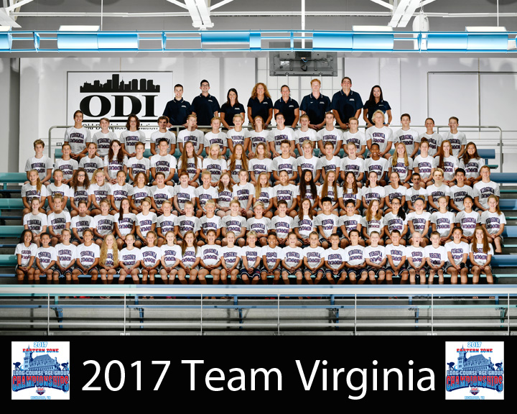

Zone Team Pictures are $20 plus $5.95 for shipping when ordered prior to meet ($25 plus $5.95 after start of meet) and fulfilled directly to swimmer's home via U.S. Mail in rigid stayflat mailers. Click here to order: https://proofing.proswimvisuals.com/sytist/lsc_pictures/eastern_zone_lsc_team_picture/.

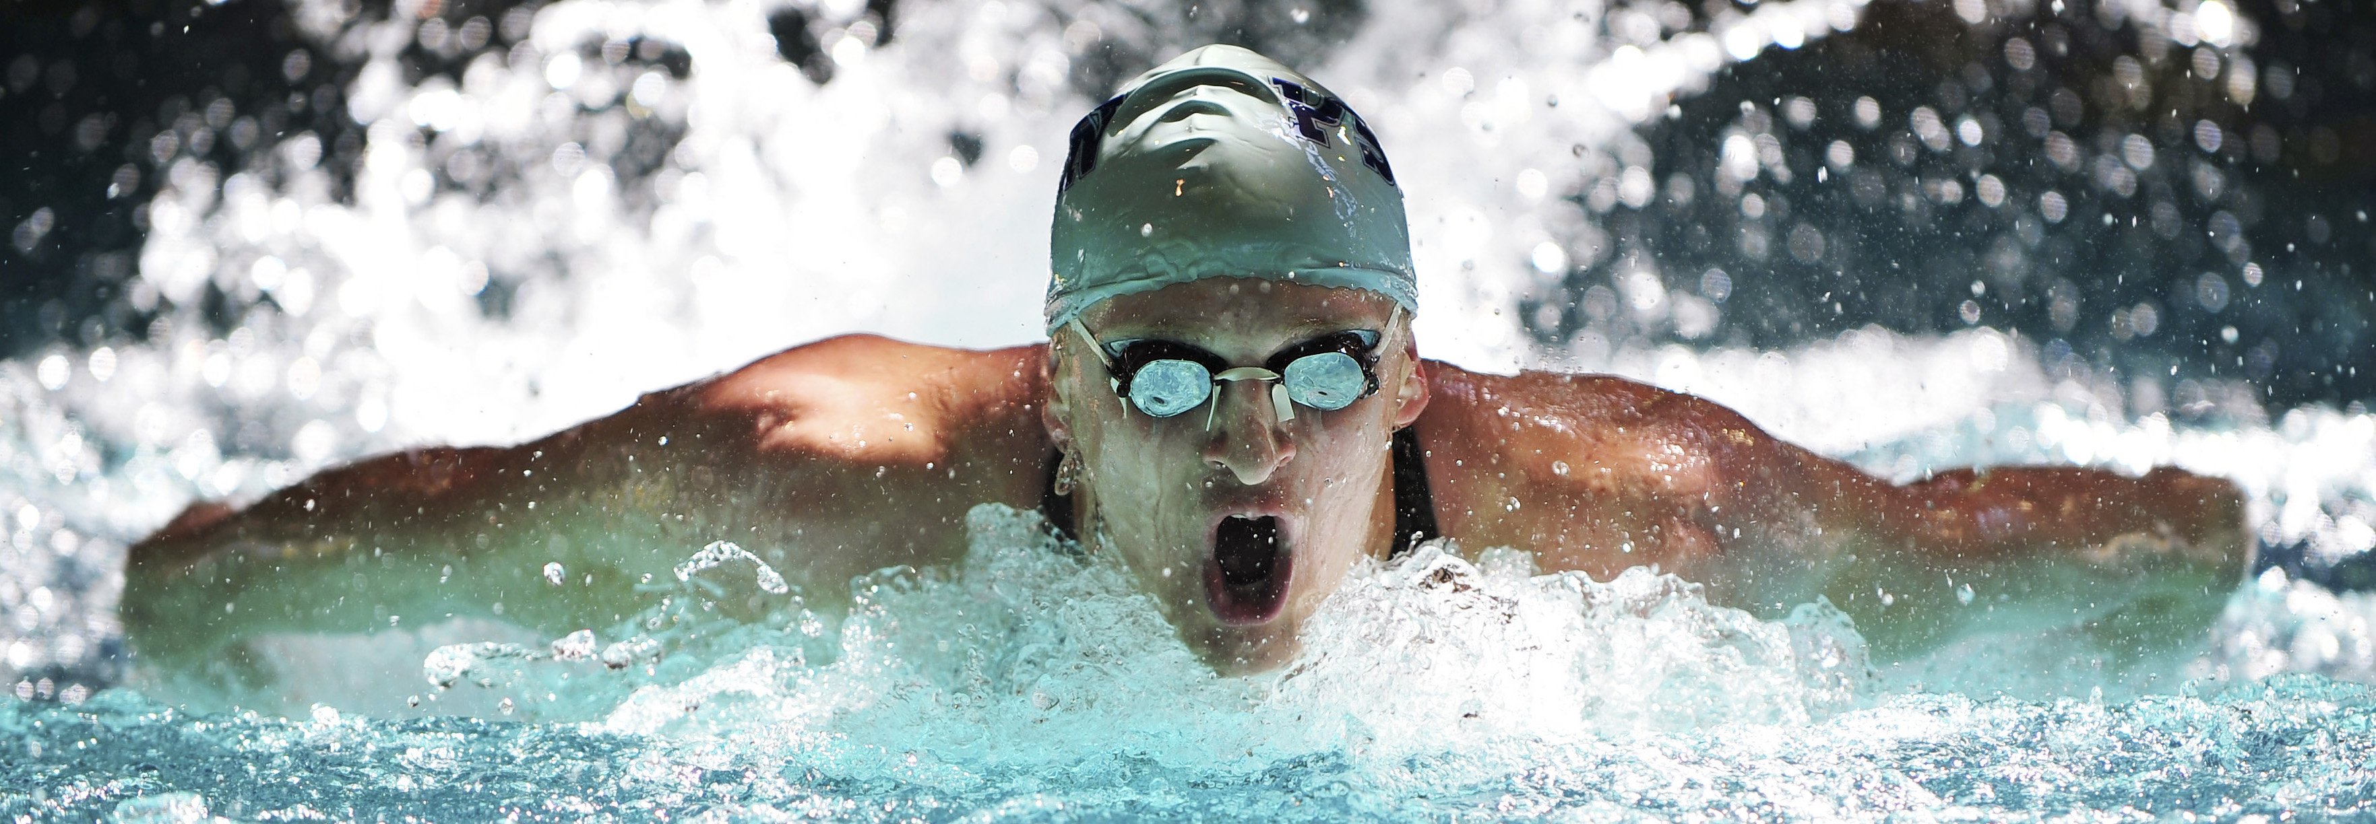

ProSwim also will be taking action photos at Zones by reservation only on a one-swimmer-per-heat, first-come/first-served basis. Please use the following link to make a pre-reservation or see a ProSwim associate on-site to reserve your swimmer’s heat(s): https://forms.proswimvisuals.com/view.php?id=67936.

For more information, please contact Mike Comer at mike.comer@proswimvisuals.com.

