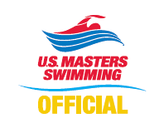
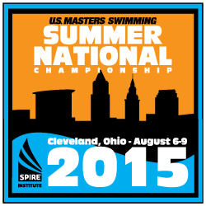
Application to Officiate
2015 U.S. Masters Swimming
Summer National Championship
Geneva, Ohio (SPIRE Institute)
August 6 - 9, 2015

Name: LMSC: or LSC:

Contact information: (Please indicate the best contact method to use)

Address:

City: State: Country: Zip:

Phone (best to use): Other Phone:

E-mail Address: Shirt Size:
-----------------------------------------------------------------------------------------------------------------------------------------------------------------------------------------------
Positions currently certified: (Indicate highest level of certification N1 / N2/ N3 for each position)
Position | Level | Expiration Date | Positions at previous USMS Nationals
Stroke & Turn
Chief Judge
Starter
Deck Referee
Certifying Organization: USMS USA-S NCAA YMCA Other:
Have you previous worked a USMS National Championship? Yes_______ No ______
-----------------------------------------------------------------------------------------------------------------------------------------------------------------------------------------------
I am available to work the following sessions: All Sessions: Thursday, Aug 6th: Friday, Aug 7th: Saturday, Aug 8th: Sunday, Aug 9th:
If you also plan to compete in the meet - Event #'s you'll be competing in:
Are you looking to share a room with someone ____________________________________
-----------------------------------------------------------------------------------------------------------------------------------------------------------------------------------------------
Preference for assignment (note some positions may have already been filled):
This meet has been approved by USA-Swimming as an Officials Qualifying Meet. Please indicate where evaluation for N2/N3 certification is requested and specify initial or final. Note that evaluations may be limited by the number of officials and evaluators present at the meet.
Position | 1st choice | 2nd choice | N2 | N2 - Renew | N3 - Initial | N3 - Final | N3 - Renew
Deck Referee
Chief Judge
Starter
Stroke & Turn
Wherever Needed
Uniform is white polo shirt over khaki pants, shorts or skirt, white socks and shoes.
-----------------------------------------------------------------------------------------------------------------------------------------------------------------------------------------------
Return application to the Meet Referee: Pat Baker email: pabrcb@aol.com
4662 Claremont Park Drive
Lakewood Ranch, FL 34211
(216) 387-9510
Assignments will be made at the sole discretion of the Meet Referee. All Officials will be required to attend briefings prior to the beginning of each session.
Application Deadline for Assigned Officials 07/12/15, All others 08/02/15
Thank you for your interest!

