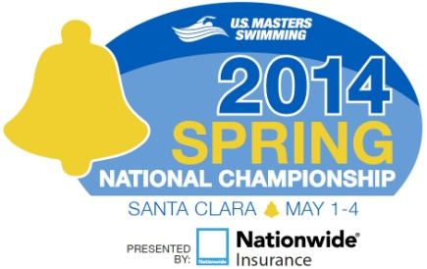
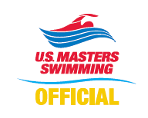
Application to Officiate
2014 Nationwide U.S. Masters Swimming
Spring National Championship
Santa Clara, California
May 1 - 4, 2014

Name: LMSC: or LSC:

Contact information: (Please indicate the best contact method to use)

Address:

City: State: Country: Zip:

Phone (best to use): Other Phone:

E-mail Address: Shirt Size:
-----------------------------------------------------------------------------------------------------------------------------------------------------------------------------------------------
Positions currently certified: (Indicate highest level of certification N1 / N2/ N3 for each position)
Level Expiration Date
Stroke & Turn
Chief Judge
Starter
Deck Referee
Administrative Referee

Certifying Organization: USMS USA-S NCAA YMCA Other:
Have you previous worked a USMS National Championship? Yes_______ No ______
-----------------------------------------------------------------------------------------------------------------------------------------------------------------------------------------------
I am available to work the following sessions:
All Sessions: Thursday, May 1st Friday, May 2nd:
Saturday, May 3rd: Sunday, May 4th:
If you also plan to compete in the meet - Event #'s you'll be competing in:
-----------------------------------------------------------------------------------------------------------------------------------------------------------------------------------------------
Preference for assignment (note some positions may have already been filled):
This meet has been approved by USA-Swimming as an Officials Qualifying Meet. Please indicate where evaluation for N2/N3 certification is requested and specify initial or final. Note that evaluations may be limited by the number of officials and evaluators present at the meet.
Admin Referee: Deck Referee: Chief Judge:

Starter: Stroke & Turn: Wherever needed:
Uniform is white polo shirt over navy pants, shorts or skirt, white socks and shoes.
-----------------------------------------------------------------------------------------------------------------------------------------------------------------------------------------------
Return application to the Meet Referee: Jacki Allender email: seewun@proaxis.com
2512 NW Acey Way
Corvallis, OR 97330
(541) 753-5681
Assignments will be made at the sole discretion of the Meet Referee. All Officials will be required to attend briefings prior to the beginning of each session.
Application Deadline for Assigned Officials 02/15/14, All others 05/01/14
Thank you for your interest!

