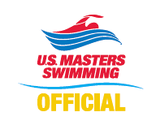
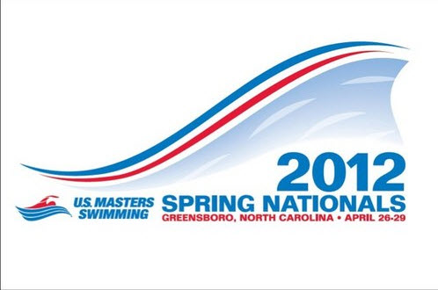
Application to Officiate
U.S. Masters Swimming
2012 Spring National Championships
Greensboro, North Carolina
April 26-29, 2012

Name: LMSC: or LSC:

Contact information: (Please indicate the best contact method to use)

Address:

City: State: Country: Zip:

Phone (best to use): Other Phone:

E-mail Address: Shirt Size:
-----------------------------------------------------------------------------------------------------------------------------------------------------------------------------------------------
Positions currently certified: (Indicate highest level of certification N1 / N2/ N3 for each position)
Level Expiration Date
Stroke & Turn
Starter
Deck Referee
Administrative Referee

Certifying Organization: USMS USA-S NCAA YMCA Other:
-----------------------------------------------------------------------------------------------------------------------------------------------------------------------------------------------
I am available to work the following sessions:
All Sessions: Thursday, April 26th: Friday, April 27th:
Saturday, April 28th: Sunday, April 29th:
If you also plan to compete in the meet - Event #'s you'll be competing in:
-----------------------------------------------------------------------------------------------------------------------------------------------------------------------------------------------
Preference for assignment (note some positions may have already been filled):
This meet has been approved by USA-Swimming as an Officials Qualifying Meet. Please indicate where evaluation for N2/N3 certification is requested and specify initial or final. Note that evaluations may be limited by the number of officials and evaluators present at the meet.
Admin Referee: Deck Referee: Chief Judge:

Starter: Stroke & Turn: Wherever needed:
Uniform is white polo shirt over navy pants, shorts or skirt), white socks and shoes.
-----------------------------------------------------------------------------------------------------------------------------------------------------------------------------------------------
Return application to the Meet Referee: Joel Black email: Joelblack@mindspring.com
7570 Brookfield Drive
Lewisville, NC 27023
(336) 817-2838
Assignments will be made at the sole discretion of the Meet Referee. All Officials will be required to attend briefings prior to the beginning of each session.
Application Deadline for Assigned Officials 04/01/12, All others 04/15/12
Thank you for your interest!

