Step 1: go to www.metroswimshop.com/vazone

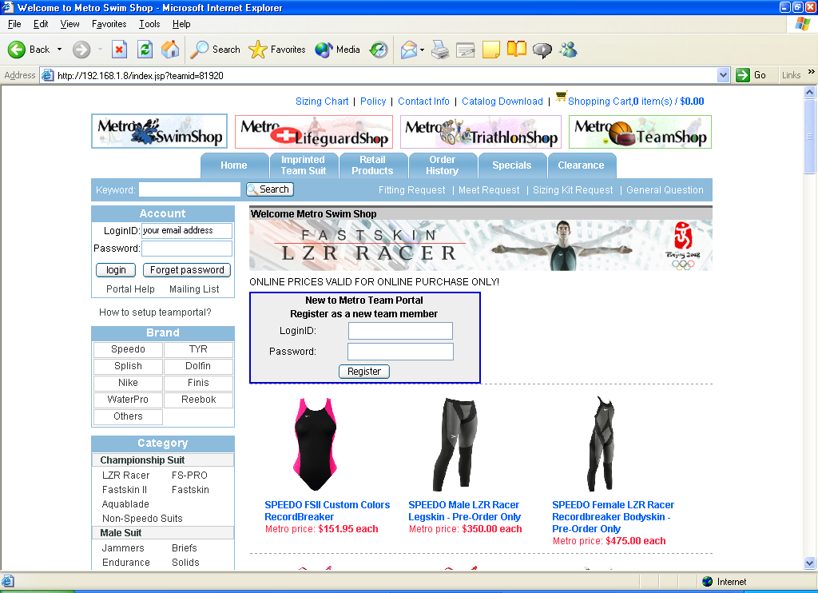

Step2: Fill out the box above. Please use your email address as your LoginID.

Step 3: Fill out the form below after you click the “Register” button.
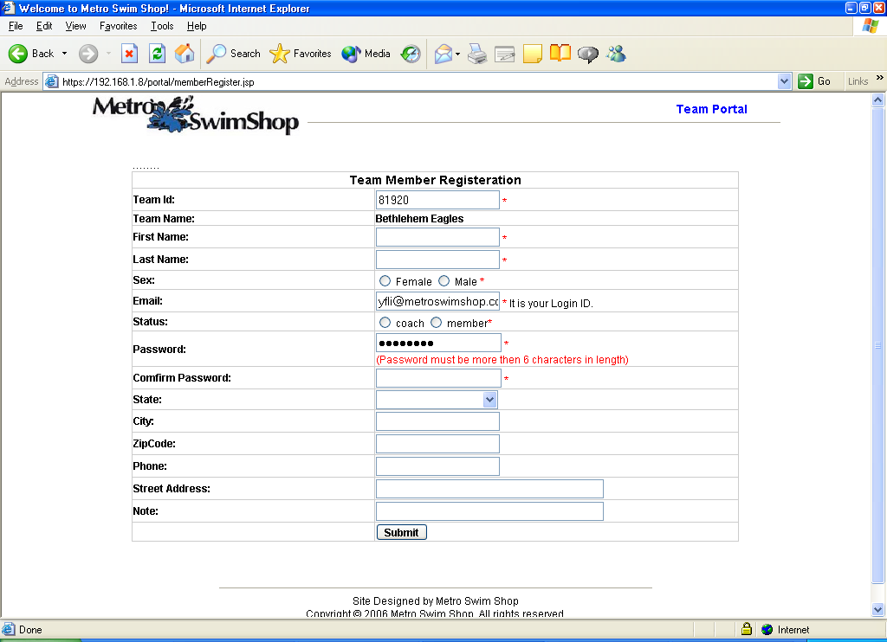
Step 4: After you fill out the form, click the “Submit” button, the page will direct you to the portal site.
The portal will open on Tuesday July 14th for athletes with 4 or more cuts
And will close Monday, July 27th at 10am.
TO ENSURE ALL ATHLETES RECEIVE A COMPLETE UNIFORM, ORDER ONLY 1 OF EACH ITEM.
Only orders from team members will be shipped, all other orders will be canceled.

