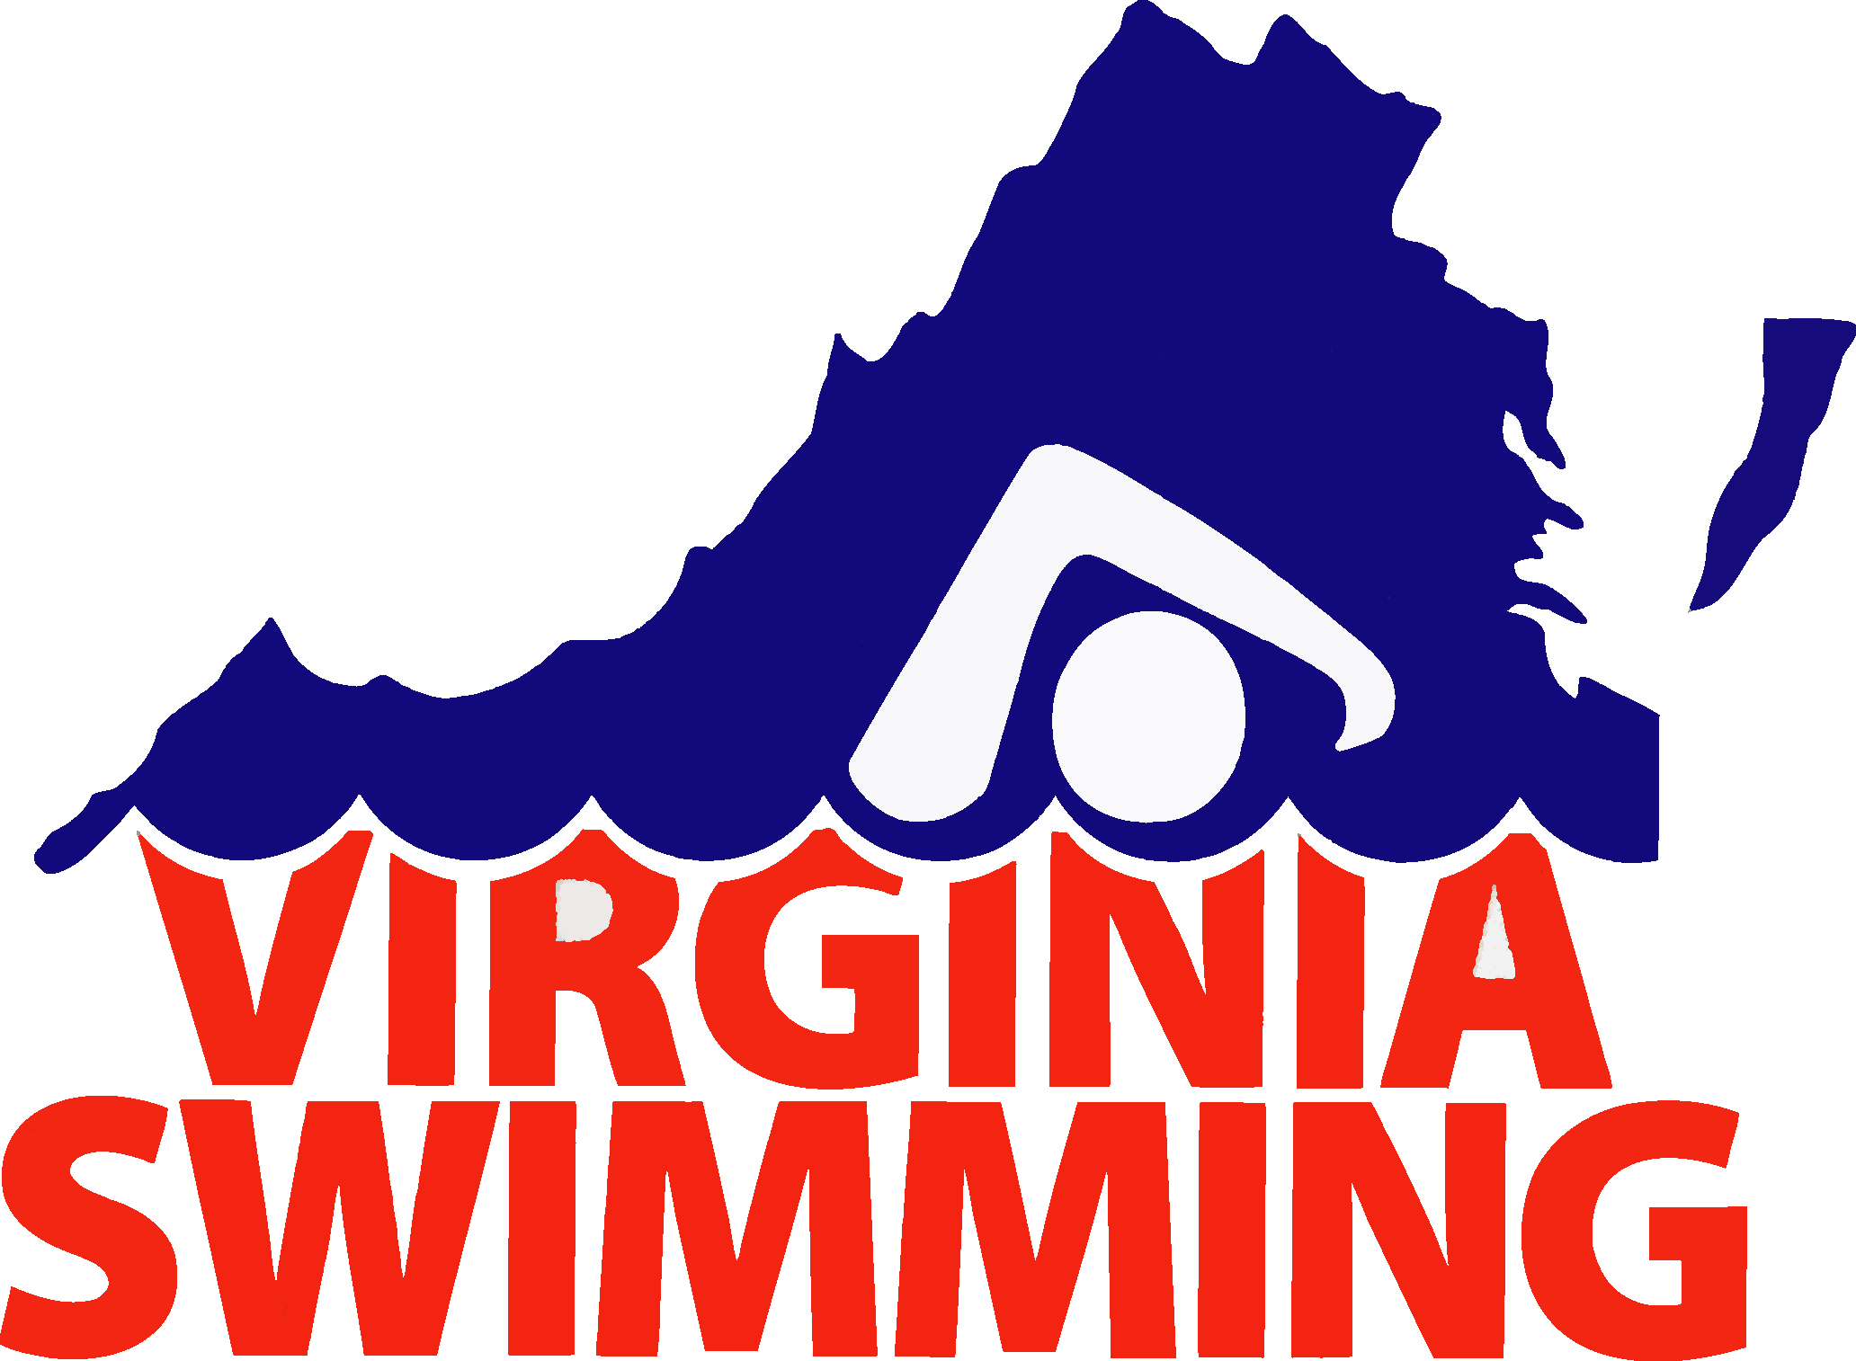
Virginia Swimming Inc.

Reimbursement Request Form

Date of Request:

Expense Reimbursement (for purchases or travel made for Virginia Swimming and paid for by the requestor). Please attach receipts.
Check Request (for a payment to be made to a vendor for materials or services provided to Virginia Swimming). Requires approval of a Committee Chair, Administrative Vice-Chair, or the General Chair.

Pay to:

Address:
Email:

Telephone: |  | Amount: | $

Purpose:

Requester’s Signature:

Approved by: |  | Title:

Forward request to: | Bob Rustin  8208 Chainmale Road  North Chesterfield, VA 23235  804-276-9220

Amount Paid: | $ | Date: |  | Check #:

